Referral Program Guideline(Exclusive Level)
1. How to find your Referral Link
In the RedotPay app, go to the [Invite friends] section. Tap to enter the Referral Program page.
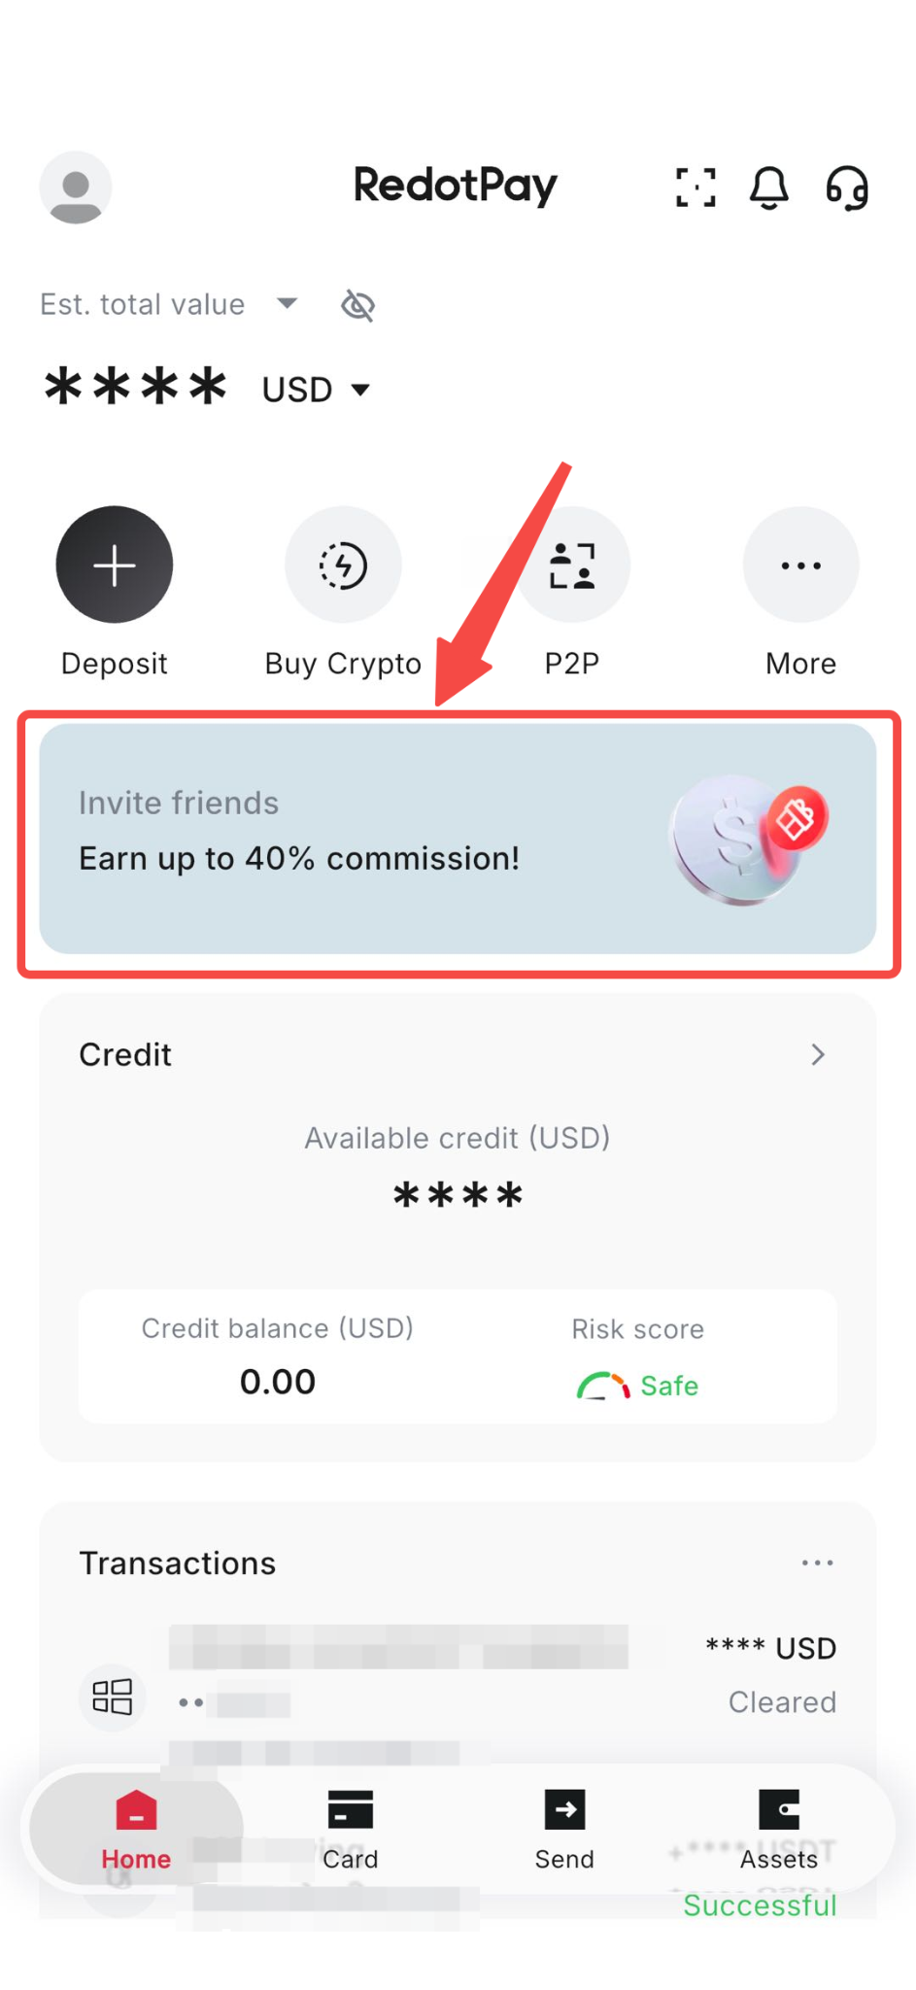

Your own invitation code and referral link are in the "Invitation Method" section. You can copy your unique referral link or invitation code.
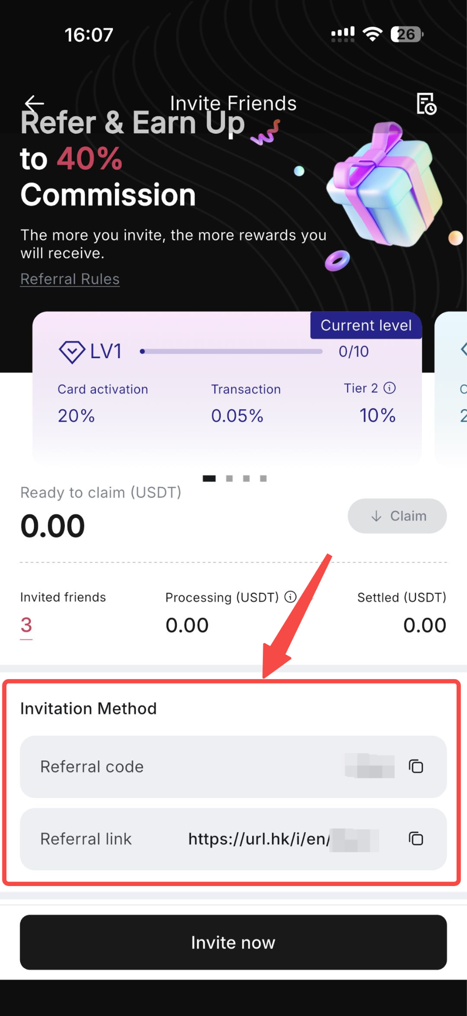
After clicking Invite now, you can directly share the invitation link and invitation code to social media.
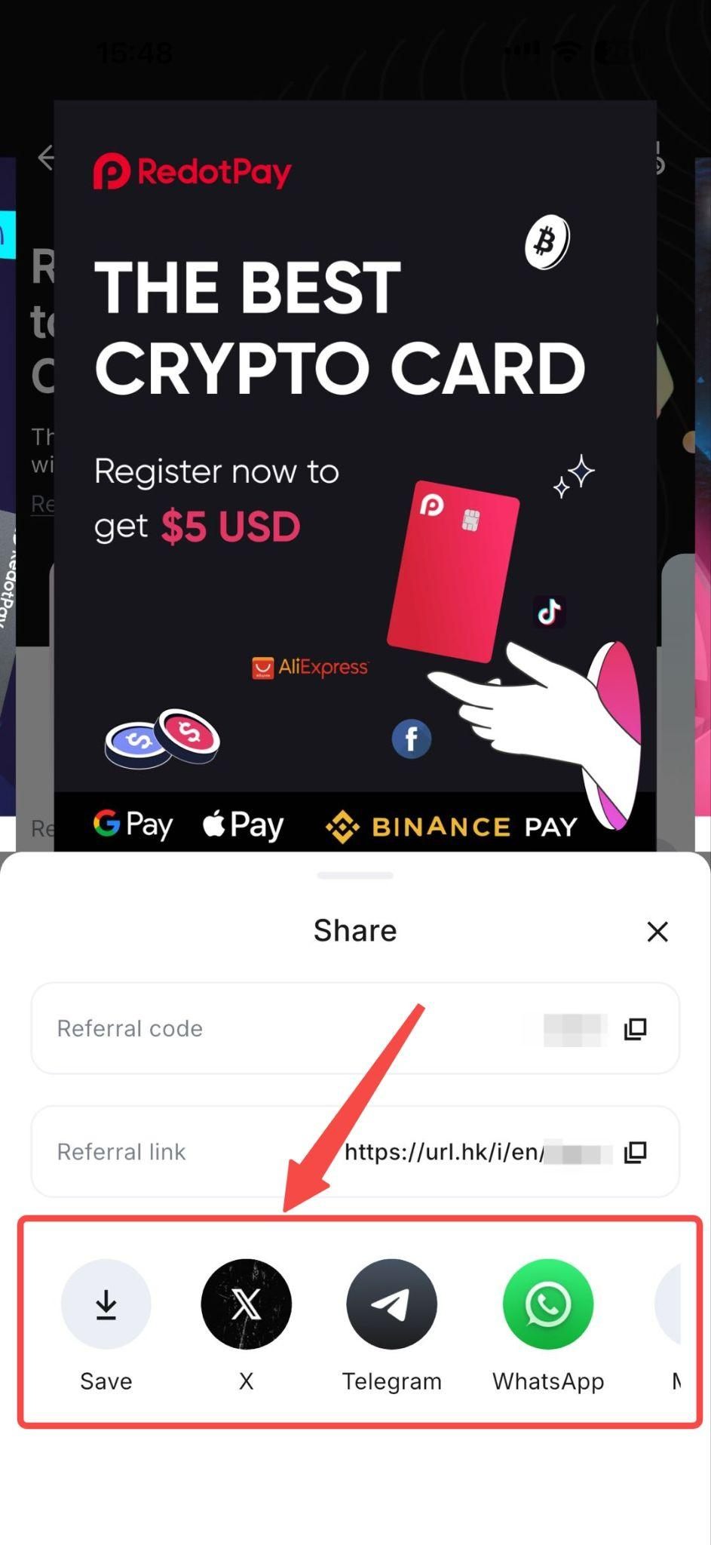

*Note: The referred user must use your link to register or enter your code during sign-up.

2. Commission Structure
Card Activation Commission
· Earn 40% commission based on the actual amount paid by the user
· Virtual Card → $4
· Physical Card → $40
Transaction Commission
· Earn 25% commission from the users’ transactions

2. How Commission is Calculated
· Card activation commission is always based on the final amount paid by the user
· If a discount is applied, the commission will be adjusted accordingly
Example:
· User pays $10 → $4
· User pays $8 (after discount) → $3.2

3. Special Case
· If a user activates a card with a 50% discount. No activation commission will be generated.
Transaction commissions still apply.
· You will earn 25% of the transaction fees paid by your users.

4. Settlement TimelineCard
Card Activation Commission
· Settled on the same day the user activates the card
Transaction Commission
· Settled on the 30th day after the transaction occurs
5. Partnership & Stability
· Your commission rate (40% + 25%) remains stable as long as the partnership is active

6. Important Notes
· Please read the marketing guidelines before starting the promotion.
· Please ensure that your promotional activities strictly comply with the marketing guidelines.
· Any misuse, abuse, or invalid traffic may affect commission settlement.
· RedotPay reserves the final right of interpretation.

